Kubernetes Task-05
- Create a namespace dev-environment and apply a resource-based quota that restricts the number of pods to 3 and services to 2.

Step 1. Create the namespace
kubectl create namespace dev-environment
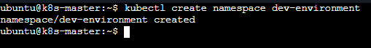

Step 2. Create the ResourceQuota YAML
vi resource-quota.yaml and add

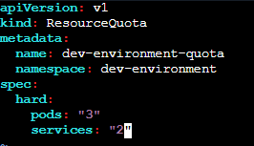
Save and exit.

Step 3. Apply the quota
kubectl apply -f resource-quota.yaml
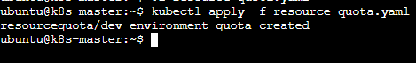

Step 4. Verify the namespace
kubectl get namespace dev-environment
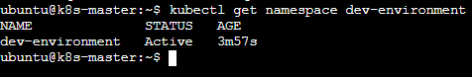

Step 5. Verify the ResourceQuota
kubectl get resourcequota -n dev-environment
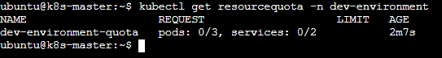
2. Create a pod in the prod-environment namespace with 0.2 CPU and 200Mi memory requests, and 0.5 CPU and 500Mi memory limits.

Step 1. Create the prod-environment namespace
kubectl create namespace prod-environment

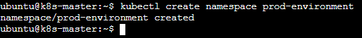
Step 2. Create the Pod YAML
vi prod-pod.yaml and add

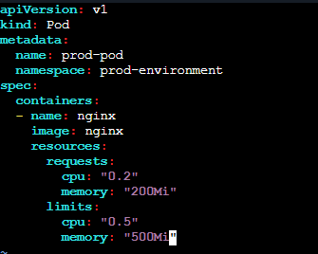
Save and exit.

Step 3. Apply it
kubectl apply -f prod-pod.yaml

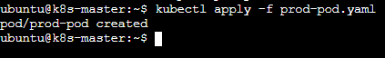

Step 4. Verify
kubectl get pod -n prod-environment
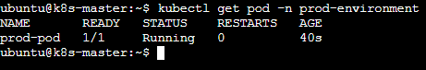
Step 5.Check the resource settings:
kubectl describe pod prod-pod -n prod-environment

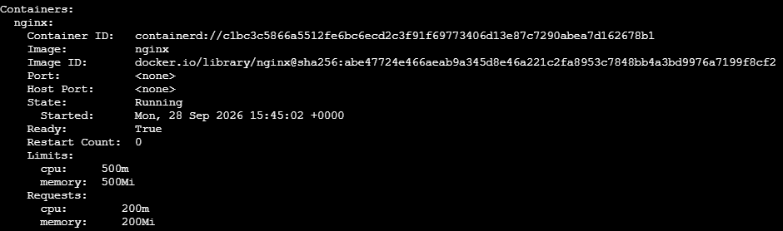
3. In the staging-environment namespace, set a LimitRange that assigns default CPU and memory limits (300m CPU, 600Mi memory) and applies a minimum and maximum CPU.

Step 1. Create the namespace
kubectl create namespace staging-environment

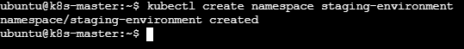

Step 2. Create the LimitRange
vi staging-limitrange.yaml and add

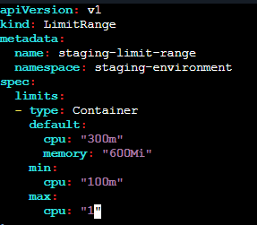

Save and exit.

Step 3. Apply it
kubectl apply -f staging-limitrange.yaml

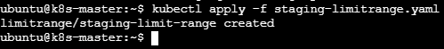

Step 4. Verify
kubectl get limitrange -n staging-environment

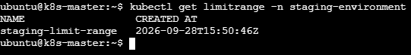
For details:
kubectl describe limitrange staging-limit-range -n staging-environment

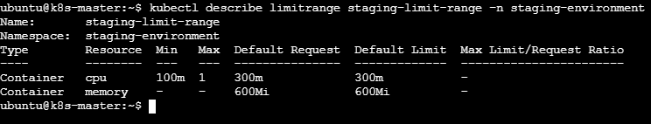
4. Create a pod and a NodePort service in the default namespace, then create another pod in the test namespace and communicate between them using Service DNS.

Step 1. Create the Pod in default
kubectl run nginx-pod --image=nginx

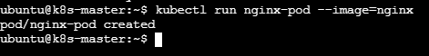
Verify:
kubectl get pod nginx-pod
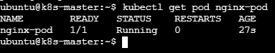

Step 2. Create the NodePort Service

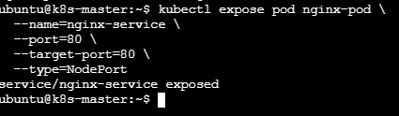
Verify:
kubectl get svc nginx-service
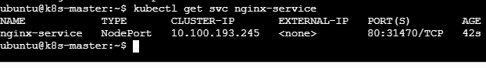

Step 3. Create the test namespace
kubectl create namespace test
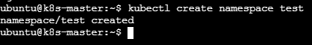

Step 4. Create another Pod in test
Use curlimages/curl because it already contains curl:
Now we are inside the test pod:
~ $

Step 5. Communicate using Service DNS
Because the Service is in the default namespace, use:
curl http://nginx-service.default.svc.cluster.local
We have to receive the Nginx HTML response:
Later exit out of container.
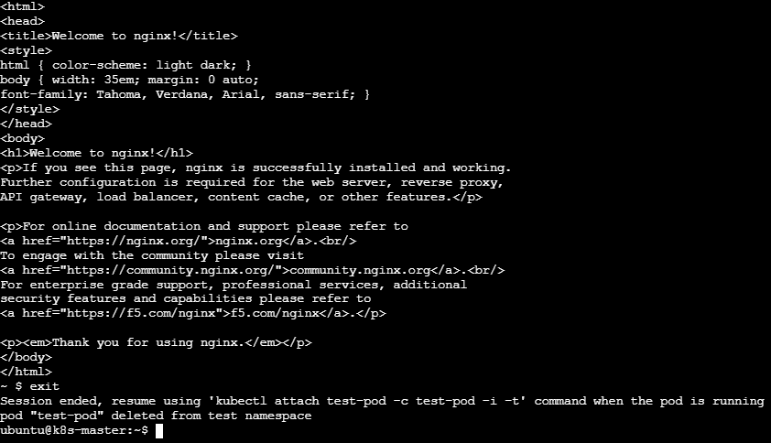
5. Apply a LimitRange with a max limit/request ratio of 2 for memory in the performance-environment namespace, and test by creating a pod with mismatched resource requests and limits.

Step 1. Create the namespace
kubectl create namespace performance-environment

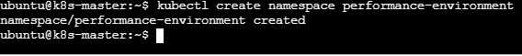

Step 2. Create the LimitRange
vi performance-limitrange.yaml and add

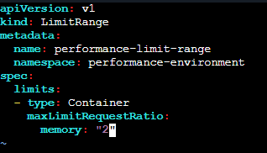

Save and exit.
Step 3. Apply it:
kubectl apply -f performance-limitrange.yaml
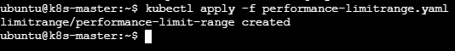

Step 4. Verify the LimitRange
kubectl describe limitrange performance-limit-range -n performance-environment
You should see:
Max Limit Request Ratio:
memory: 2
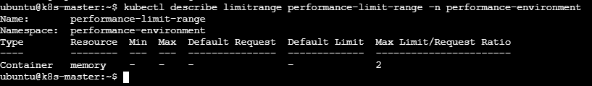

Step 5. Create a Pod with mismatched memory
Now create a Pod where:
- Memory request = 100Mi
- Memory limit = 500Mi
The ratio is:
500Mi / 100Mi = 5
But the allowed maximum ratio is 2, so Kubernetes should reject it.
Step 6 .Create vi test-ratio-pod.yaml
Add:
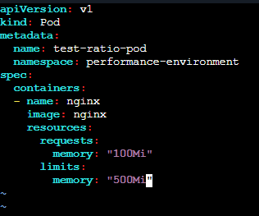
Save and exit.
Step 7. Apply:
kubectl apply -f test-ratio-pod.yaml

Expected result
The Pod should NOT be created. You should get an error similar to:
Error from server (Forbidden):
pods "test-ratio-pod" is forbidden:
memory max limit to request ratio per Container is 2,
but provided ratio is 5

